**Model Development Phase Template**

Date

25

June 2222222024

2024

T

eam

ID

739711

Project

T

itle

Movie Box Office Gross

-

Prediction

Maximum

Marks

4

Marks

**Initial Model Training Code, Model Validation and Evaluation Report**

The initial model training code will be showcased in the future through a screenshot. The model validation and evaluation report will include classification reports, accuracy, and confusion matrices for multiple models, presented through respective screenshots.

**Initial Model Training Code:**

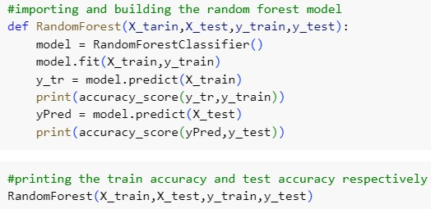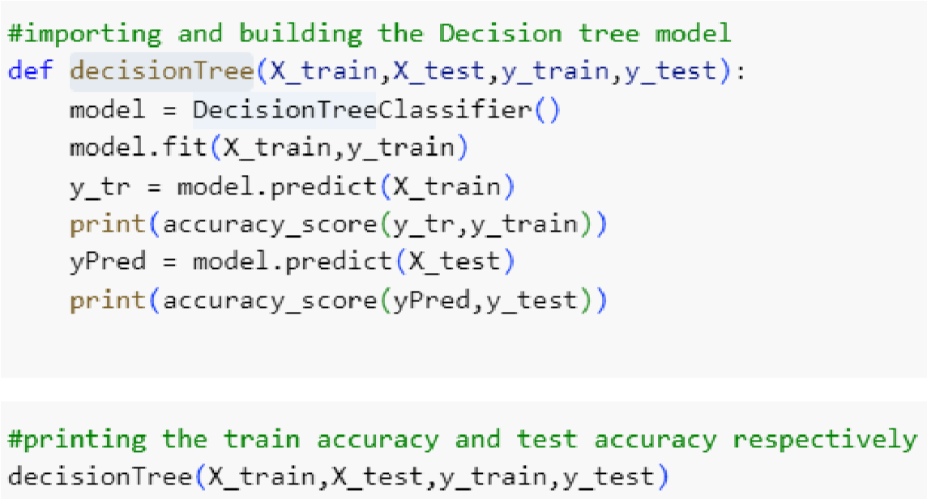

**Model Validation and Evaluation Report:**

|  |  |  |  |
| --- | --- | --- | --- |
| **Model** | **Classification Report** | **F1**  **Scor e** | **Confusion Matrix** |
| Random  Forest |  | 81 % |  |